Date: Mar 23/2015

**User Interface Programming I**

**Group 4: Stormy Weather Flying Dutch Man**

The Different Screen Shots of Our Application:

1. **The Home and Login Page:-**

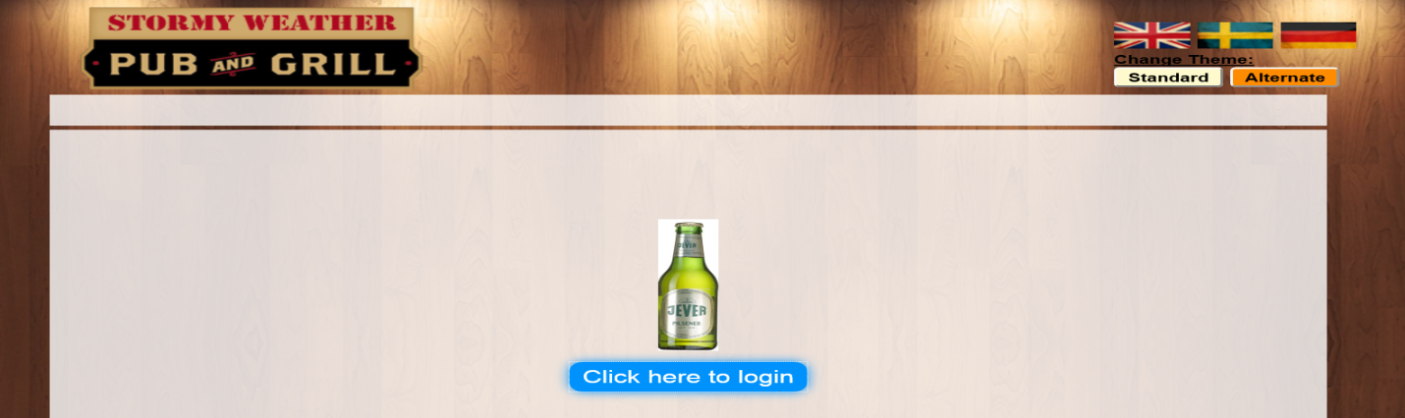

Login page:

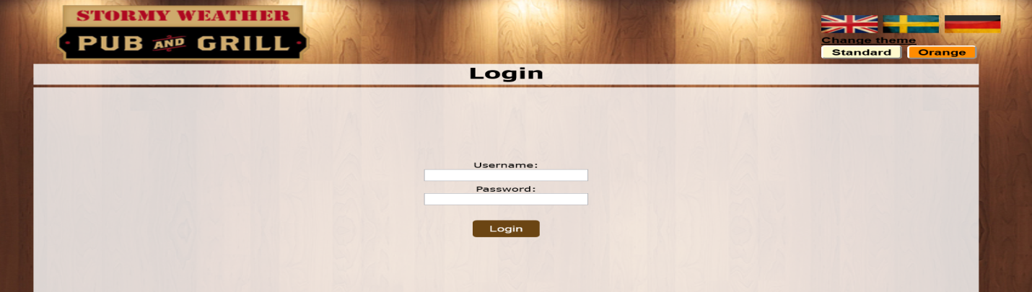

1. **Order Page**

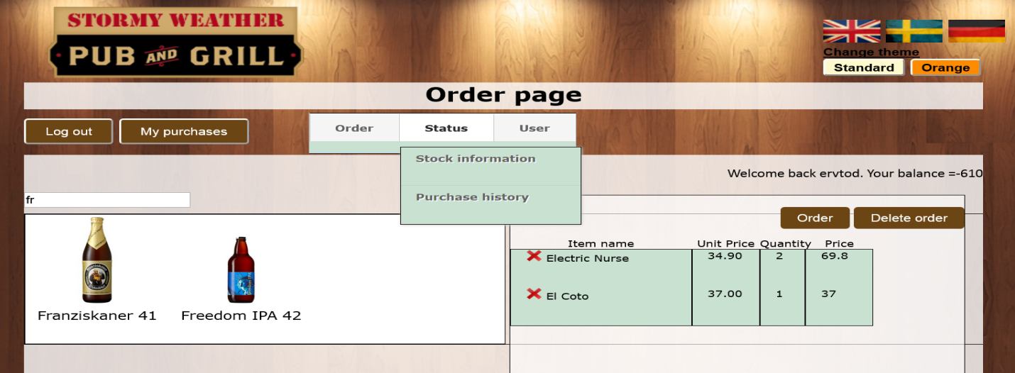

1. **Stock Information Page**

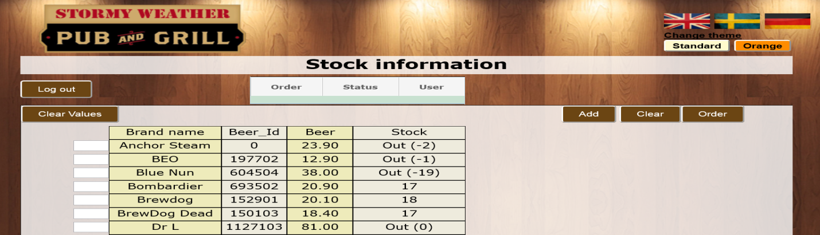

1. **New user registration Page**

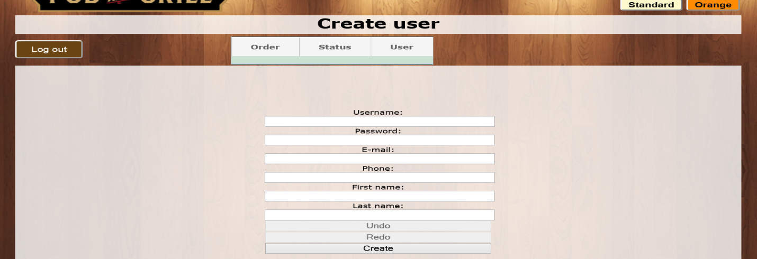

1. **The different Themes we use:**

We used orange theme as an alternative Theme.

